Boolean in python

**Python** **boolean** type is one of the built-in data types provided by Python, which represents one of the two values i.e. True or False. Generally, it is used to represent the truth values of the expressions. For example, 1== 0 is True whereas 2<1 is False.

## Python Boolean Type

The boolean value can be of two types only i.e. either True or False. The output ***<class ‘bool’>*** indicates the variable is a boolean data type.

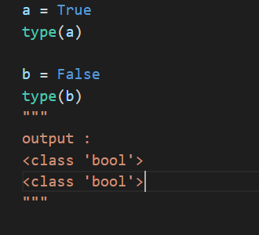

## Evaluate Variables and Expressions

We can evaluate values and variables using the **Python bool()** function. This method is used to return or convert a value to a Boolean value i.e., True or False, using the standard truth testing procedure.

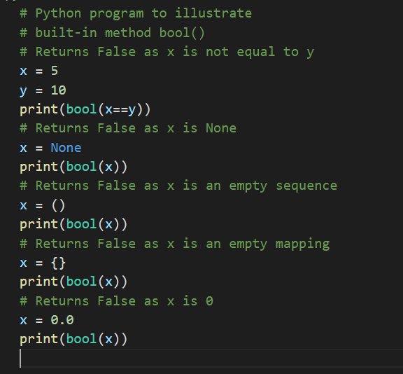

We can also evaluate expression without using the bool() function also. The Booleans values will be returned as a result of some sort of comparison. In the example below the variable res will store the boolean value of False after the equality comparison takes place.

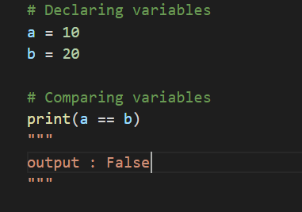

## **Integers and Floats as Booleans**

Numbers can be used as bool values by using Python’s built-in ***bool()*** method. Any integer, floating-point number, or complex number having zero as a value is considered as False, while if they are having value as any positive or negative number then it is considered as True.

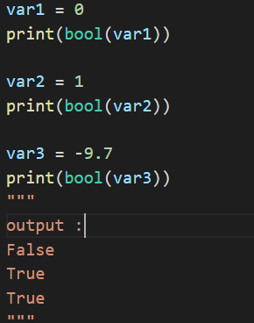

## **Boolean Operators**

Boolean Operations are simple arithmetic of True and False values. These values can be manipulated by the use of boolean operators which include **AND, Or, and NOT**. Common boolean operations are –

* or
* and
* not
* == (equivalent)
* != (not equivalent)

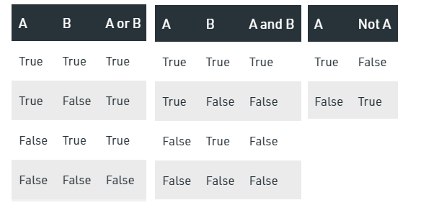

### **Python Boolean OR Operator**

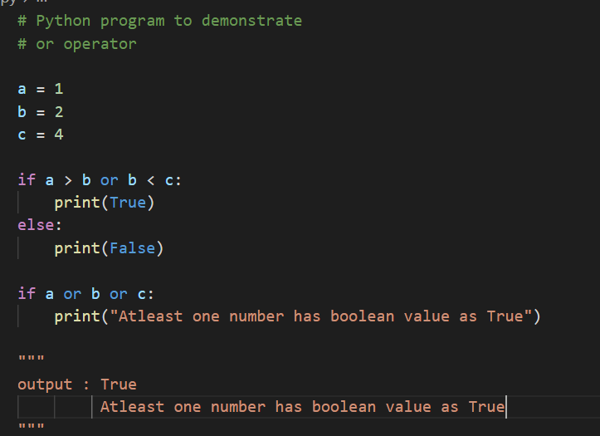

### **Boolean And Operator**

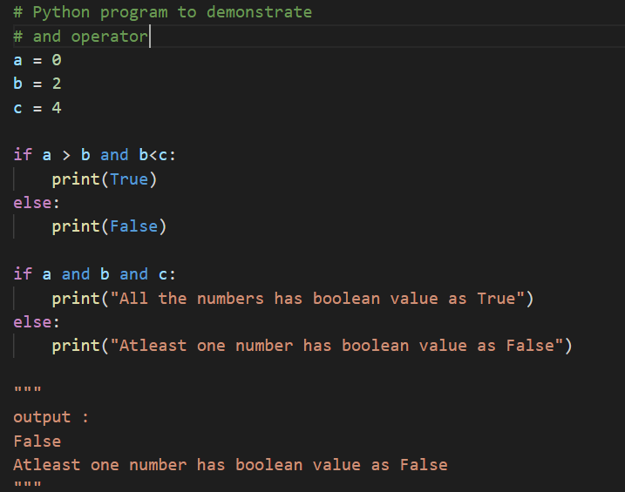

### **Boolean Not Operator**

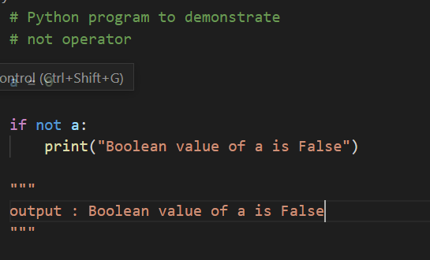

### Boolean == (equivalent) and != (not equivalent) Operator

Both the operators are used to compred two results. == (equivalent operator returns True if two results are equal and != (not equivalent operator returns True if the two results are not same.

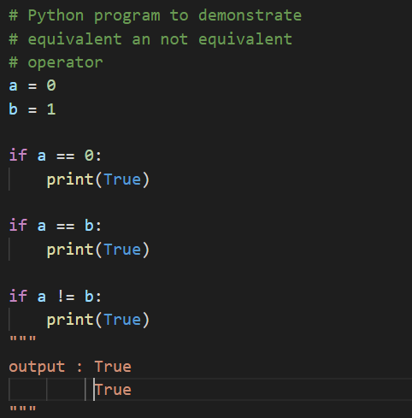

### is Operator

The is keyword is used to test whether two variables belong to the same object. The test will return True if the two objects are the same else it will return False even if the two objects are 100% equal.

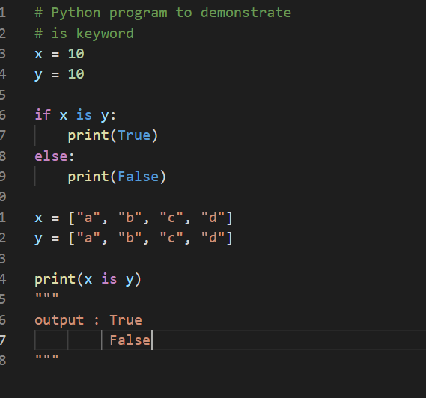

### in Operator

in operator checks for the membership i.e. checks if the value is present in a list, tuple, range, string, etc.

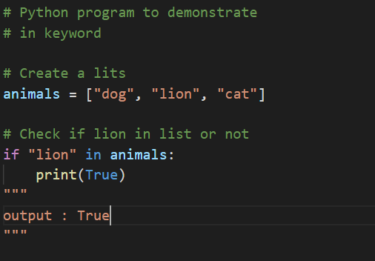

None Type:

NoneType is the type for the None object, which is an object that indicates *no value*. None is the return value of functions that "don't return anything". It is also a common default return value for functions that search for something and may or may not find it; for example, it's returned by re.search when the regex doesn't match, or dict.get when the key has no entry in the dict. You cannot add None to strings or other objects.